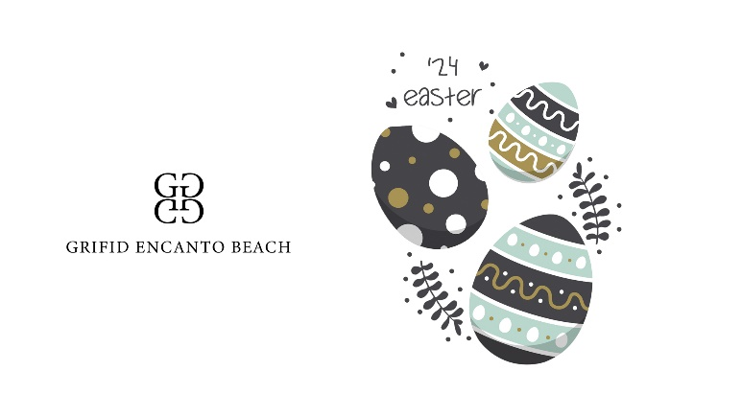1st May/Easter Hotel Fact Sheets
Accommodation
- Period for stay – 30.04.24-06.05.24
- Check in time 14:00, check out till 11:00
- Check-in starts with lunch and check – out ends with breakfast
- Early check-in after 10.00 a.m. and/or late check-out after 11.00 noon is 49.00 BGN per room
- Parking place – limited, against charge – 20.00 BGN per day
- In room safe – free of charge
- Tea and coffee-making facilities in all rooms
- Free Wi-Fi connection
- FREE ACCESS TO SPA CIRCUIT IN ENCANTO MEDISPA - saunas, steam bath, ice fountain, Kneipp path, indoor pool, relax zone. Access to the SPA CIRCUIT (excluding the indoor pool) is ONLY for adults 16 +.

Restaurants and Bars – ULTRA ALL INCLUSIVE
- Rich and various Buffets for breakfast (07.30-10.00), lunch (12.30-15.00) and dinner (18.00-21.00)
- Festive Easter Lunch Buffet on 05.05.2024 with Easter Eggs, Easter Bread, Roast Lamb, Green Spring Salad, Easter Muffins for Children
- Different theme buffet for dinner every evening
- Continental A la Carte Breakfast (10.00-12.00)
- Variety of cookies, coffee and tea (14.30-17.00)
- Snack at the Beach Club restaurant: Burgers, Hot Dog, Pizza, Sandwiches, Waffles (12.00-17.00)
- One a la carte dinner per stay (reservation required) (18.30-21.30h.) – the indoor a la carte restaurant
- Selected Local and International Alcoholic and Non-alcoholic Drinks from 07.30 till 01.00h., offered in the hotel bars.
- Daily refilled mini bar with beer, soft drinks and mineral water

Animation and fun
- Every day the customers can join and enjoy our sports entertainment program with the professional entertainment team of GRIFID HOTELS.
- Sport & Fun: SPECIAL PROGRAM DESIGNED FOR EGG-CELLENT MOMENTS
- Well Fit: Fitness, Dance Aerobic, Pilates, Stretch & Relax, Zumba, Aqua Gym Body styling, Aqua Fit
- Dance lessons: Salsa, Bachata, Cha-Cha
- Every day- evening shows and entertainment program.

05.05.2024 – Easter special
✓ Easter celebration ceremony for health and prosperity with Priest
- Evening Entertainment activities in lobby bar
For Children:
- Mini club with GRIFID children animators and daytime entertainment program for guests aged 4-12 with variety of activities:
- Popular Easter Activities: Easter Coloring Pages, Easter Clip Art - Easter Eggs, Bunnies and More, Jeweled Easter Eggs, Napkin Applique Easter Eggs,
- Top Bunny Crafts: Bunny Ears for Kids, Bunny Party Hats, Easter Bunny Bag, Easter Pom-pom Bunny
- Baskets of Fun: Egg Hunt Basket, Easter Bunny Basket
- Easter Decorations: Easter Crafts, Egg Carton Flowers, Easter Egg Garland, Paper Napkin Easter Decorations
- Games & Activities: Special Activities for the Whole Family plus: Games and Competitions: Easter Egg Race, Minute to Win it Games, Easter Bunny Party, Easter Word Puzzles, Egg Toss, Peter Cottontail Game, Easter Olympic Games, Giant Egg Hunt
- Mini Disco & Funny games every day from 20 h.
- Opening hours for the mini club – 10.00-12.30 and 15.00-17:30

Sports and relaxation
- MediSPA center with 32 treatment rooms (2300 sq. m ) - variety of programs for health, relaxation, detox, wellness and recovery; (08.00-20.00)
AQUAtic Floor - Mud treatments and therapies, water treatments, high class professional equipment from German company “Unbescheiden” ( electro galvanic, hydro massage, underwater massage tubs ( tangent bathtubs ), four – cell bathtub, dry floating beds ( beds for dry floating “Jovance” ), Fango - Paraffin , Charcot shower and colon therapy.
SPA Circuit - Three different saunas – aroma, infrared and finnish, Steam bath, Hammam, Ice fountain, shock shower, Kneipp path, glass roof heated indoor pool overlooking the sea with sliding window walls and aquatonic pool with relax zone.
VITAlity Floor - Large physiotherapy room equipped with ultrasound, magnet therapy, oxygen treatment, press therapy, body former, reflexology, infrared lamp, electrophoresis, vacuum therapy, interference therapy, ultrasonic device, inhaler, Bioptron light therapy, cryotherapy equipment, cosmetic and beauty salon.
- Fitness center with sea view panorama - innovative Techno gym® equipment including its Kinesis line.
- Glass roof indoor pool overlooking the sea with removable window walls.
- Beauty salon (at extra charge)
- Wellness and beauty treatments, Classic and variety of massages (at extra charge)

